TOPIC 1:

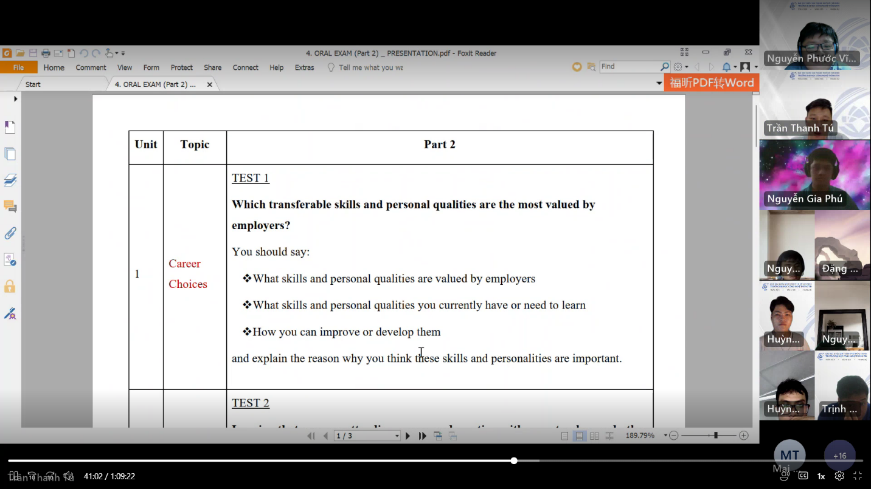

Thanks for asking me, that is a good question that is very interesting for me to answer. I think

TOPIC 2:

TOPIC 3:

TOPIC 4:

TOPIC 5:

TOPIC 6: Describe a premium service that you know or have axperienced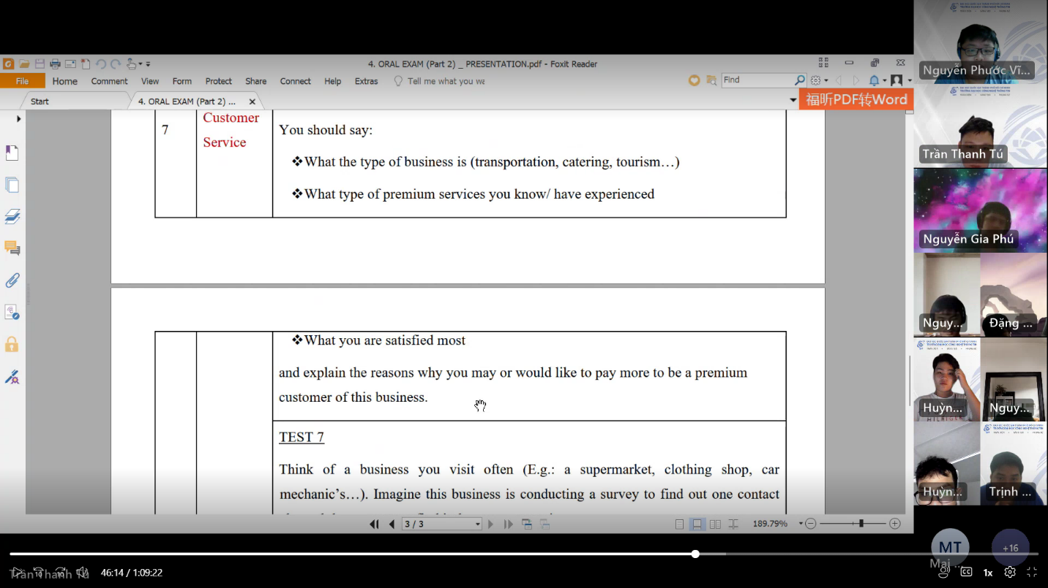

TOPIC 7:

TOPIC 8: 